Mrs. McCauley's
Camp Newsletter
9/21/18
Important Dates  Saturday, September 22  First day of Fall!  Our Special Schedule:  Monday: Music  Tuesday: School Counseling (Guidance)  Wednesday: Art  Thursday: P.E.  Friday: Technology and Library | What we are learning  Language Arts  This week we are on to letter Cc! We are focusing on the hard C sound (carrot) rather than the soft C sound (celery). Our center activities had students practicing their handwriting with pencil and paper and with the iPads, matching uppercase and lowercase letters, building each other's names, and identifying rhyming words, and hearing beginning letter sounds. Students also completed their STAR assessments for early literacy.  Math  We spent a lot of time getting in the routine of our math journals this week. Students are working at their own pace to learn about numbers 1-20. The class was also introduced to 5-frames, which we used as a visual for seeing numbers 1-5 in different groupings (I.e. 1 and 3 make 4, 2 and 2 make 4...). We also learned a card game called “Top It.”  Social Studies  This week, we started talking managing our impulsivity. This is a Habit of Mind that will help us as learners and as community members! When we break down those big words, managing our impulsivity means that we think before we act.  Science  You may have noticed our weather mobiles hanging in our room at the open house to show some of the more common types of weather that we see. We also conducted our first science experiment to test how different objects are affected by wind. Going forward, we will be recording the weather each day and looking for patterns and learning about the importance of weather forecasting.  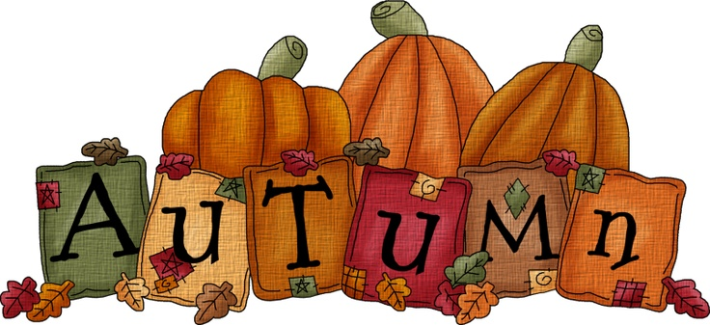
Notes

- Please send a note with your child to indicate any changes in their usual afternoon transportation. These notes or other information can be sent in your child’s blue folder which is checked at school each day.

- Please don’t hesitate to contact me via email at hmccauley@sau80.org

Theme

- Our school-wide theme this year is “We have the right write stuff!”

